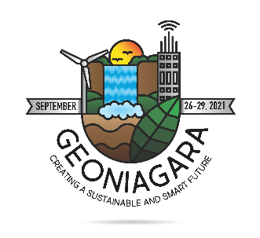
Title – Formatting guidelines for authors submitting final abstracts to GeoNiagara 2021

Author One, Author Two & Author Three
Company Name, City, Province/State, Country
Author Four & Author Five
Department of XX – University of YY, City, Province/State, Country

ABSTRACT
Final abstracts may be submitted in English or French based on the original abstract submitted and accepted. To ensure consistency in the presentations of final abstracts in the digital proceedings your final abstract must conform to this template. All final abstracts must be submitted via the on-line submission page on the GeoNiagara 2021 website by May 15, 2021.

Please ensure that you spell check your document and review it for correct grammatical English and French. The final abstracts will not be formally peer reviewed by the GeoNiagara 2021 Technical Committee for scientific correctness or to ensure adequate spelling/grammar. All presenting authors must be registered as conference delegates (or students, if applicable) to submit a final abstract.

